Manual For Farmtotable Online Trade Platform

March 10, 2015

**Requirement:**

Python, SQLite3, Django

**Python Packages Required**

* NLTK, NLTK data must be installed
* Django security session must be installed
* Scipy

**Launch The Program**

* Enter the Farmtotable directory. Run “python manage.py runserver” to start exploring.
* For error message “That port is already in use”, run “sudo fuser –k 8000/tcp” and rerun the server

**Two Ways To Navigate Through Our Site!!!**

db.sqlite3 is a preloaded database.

* The Lone Wolf:
  + Move the db.sqlite3 to a separate directory, delete all files in applications/migrations, run “python manage.py syncdb” to create a new empty database.
  + Start exploring our website with an empty back-end database
  + Register your own users as buyers or sellers and try out the different functionalities.
* In A Crowd:
  + Fixture file contains the testing data and they are preloaded into db.sqlite3. Move it to the directory to interact with it.
* The data should be pre-loaded. In case it is not loaded properly, go to farmtotable directory and run “python manage.py loaddata userprofile_fixture.json > applications.userprofile”

Fixtures to load for all the models include:

userprofile, product, order, search, rating, donation, item, cart

If cannot load one, try load the others first because some objects need to exist for the others to be created.

* The test data is randomly generated and the relations between objects might not be orderly, so we strongly suggest you to use the empty version for a better sense of how our functions work.

Testing Users:

|  |  |  |
| --- | --- | --- |
| Username | Password | Type |
| Xiaohong | a | Seller |
| Jianan | b | Buyer |

**Site Overview**

Total number of templates: 42

Technologies used: JavaScript, Html, CSS

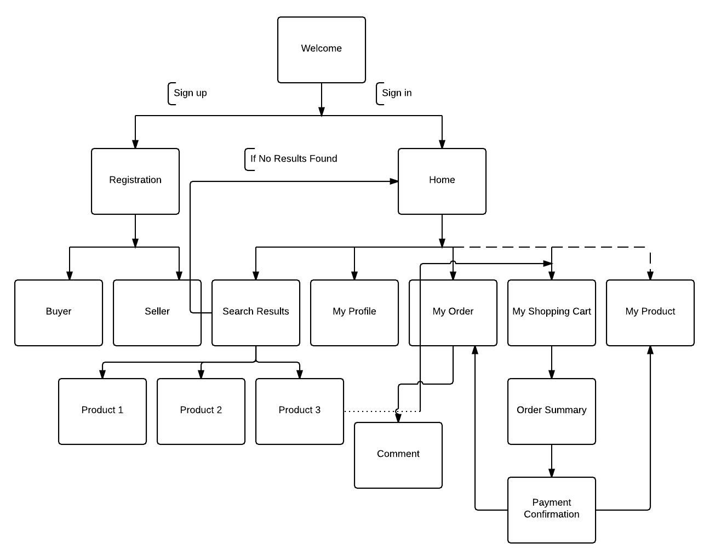

**Functionalities**

Total functionalities enabled 37

* User: Register, log in, log out, modify profile, upload files.

Search, message, like product, shop, checkout and more.

* + Seller:
    - Register product
    - Modify product
    - Cannot leave comments
    - No product will be recommended for seller
  + Buyer:
    - Being recommended product
    - Leave comments

**Special Features**

**Session security**

* + Automatically logged out after 10 minutes.
  + Automatically logged out after closing browser

**Search**

* User, buyer and guests can search
* Search history will be stored in the search model:
  + For registered users it will store the user’s profile, search term, product origin, product category and time.
* NLTK:
  + Search term is case-insensitive, order-insensitive, singular or plural insensitive
  + Can type in multiple words
  + Adjectives and nouns are interpreted through NLTK for more accurate search
* Search in index rather than making direct query to the database. Index is automatically updated each time a product is added.
* Search for key words in both product names and descriptions: product whose names contain the key term will appear first.

**Recommendation**

* Sources of data:
  + User liked product
  + User order history
  + User rating
* Two-way recommendation:

Algorithm:

* Calculate the Pearson coefficient as the indicator for similarity
* Arrays supplied:
  + index = product.id – 1;
  + value = average rating of a product or times the user bought this product
* Filter by user
  + Recommend high rated product bought by similar users
* Filter by product
  + Find your liked and highly rated product you bought
  + Recommend similar product

**Rating & Comments**

* Buyers can rate user and product
* Buyers can only rate a product after he or she places an order

**Message**

Buyers and sellers can exchange messages. Go to their profile pages.

**Shopping cart, Check out & Payment**

Currently users have their accounts registered with our website.

Upon checkout, they could choose to pay differently: online, offline or on delivery. Orders will be received and confirmed by the seller or be canceled by either party. Seller can charge extra delivery fee.

**My Finance**

Monitor your spending in the last three months and view by category.

**Further Features To Explore**

Internationalization

Balance between traffic and capacity